Backtracking Algorithms

Backtracking is a general algorithmic technique used to solve problems incrementally by trying out all possible solutions. It explores the solution space recursively and abandons (backtracks) as soon as it determines a path cannot lead to a valid solution.
Core Idea:
- Choose → Try a candidate.
- Explore → If the candidate leads towards a solution, continue recursively.
- Un-choose → If the candidate leads to a dead end, undo choice and backtrack.

15 Puzzle Problem:

A sliding puzzle consisting of a 4×4 grid with 15 numbered tiles (1–15) and 1 empty slot.

Objective: Rearrange tiles to reach the goal state:

1 | 2 | 3 | 4
5 | 6 | 7 | 8
9 | 10 | 11 | 12
13 | 14 | 15 | –

You may try out the game for better understanding: Link

Rules:

- A tile adjacent to the empty slot can slide into it.
- Only legal moves (up, down, left, right) are allowed.
- Problem: Find a sequence of moves that transforms the initial state into the goal state.

State Space Tree:
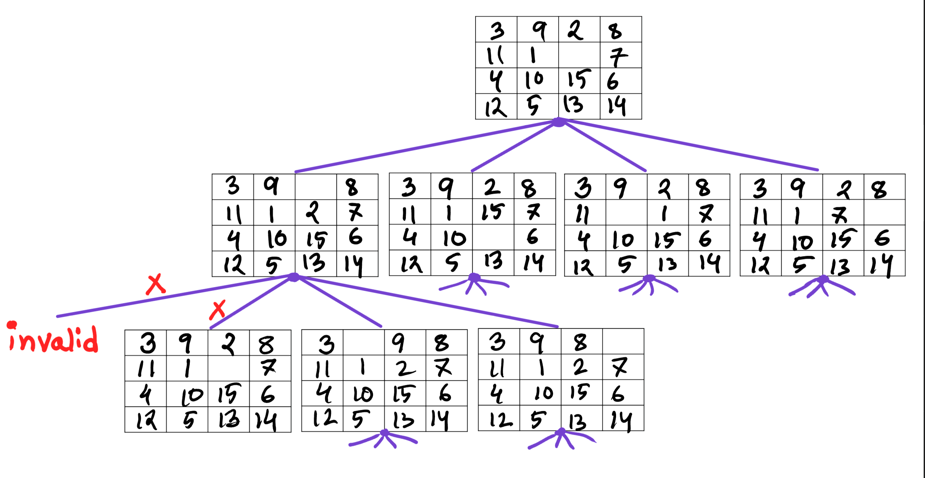

Pseudo Code:

function solve_puzzle(board, visited):

if board == goal_state:
return True # Solution found

mark board as visited

for move in possible_moves(board): # up, down, left, right
if move is valid:
new_board = apply_move(board, move)

if new_board not in visited: # To avoid getting stuck
if solve_puzzle(new_board, visited):
return True # Found solution path

# Backtrack

return False # No solution from this state
Time Complexity: The total number of states is 4⁰ + 4¹ + 4² + .. + 4^{d} = O(4^{d}), so T(n) = O(4^{d})
where d is the depth of the tree or the number of moves from the initial puzzle
state to the goal state.

How to achieve better complexity?

Use an informed search like A* (will be taught in CSE422) that guides the search toward promising states instead of exploring vast numbers of states blindly. A heuristic of A* can be a number of misplaced tiles..

8 Queen Problem

Place 8 queens on a standard chessboard (8×8) such that no two queens attack each other.

Attack Rules:

- A queen can attack another if they are in the same row
- A queen can attack another if they are in the same column
- A queen can attack another if they are in the same diagonal

Objective: Place queens so that no two share a row, column, or diagonal:

Q1
Q2
Q3
Q4
Q5
Q6
Q7
Q8

Home Assignment:
Q1) Draw the State Space Tree, Pseudo Code and Time Complexity for 8-Queen Problem.
Q2) Generalize the solution for N-Queen Problem and suggest improvements to the algorithm.

